Module 7 Portfolio Project

Portfolio Project on the Ethics of Data Analytics in Mass Shooting by The Violence-Project

Nathan Rziha

MIS581 - Capstone - Business Intelligence and Data Analytics

Colorado State University – Global Campus

Dr. Lisa Bryan

December 4, 2022

Abstract

This paper was about ensuring that The Violence-Project followed proper data analytics ethics and didn’t provide a political spin on the data they presented. It only has a little actual analytical work to validate the results shown, as it turned into more of a look at how the proper use of ethics can be done on a very political topic and the creators can provide honest results no matter the issue. Mass Shootings are a blight on the United States of America and politicians are using them as talking points but are not working to actually resolve the causes. One side wants to take guns away from private ownership because if there are no guns, then there can be no shootings. However the other side, argues that private gun ownership is their right and is protected and that private ownership helps prevent or resolves some shootings. The issue is not the guns that both sides keep focusing on, but on the reasons for the shootings in the first place. This project is a review of the ethics that data analysts need to keep in mind when they present the results of their data to the audience that it was intended for, but also on whether or not the message is honest to the data also.

Portfolio Project on the Ethics of Data Analytics in Mass Shooting by The Violence-Project

Of all the cataclysmic events to ever befall the planet, the worst was the evolution of primates into hominids. Mankind has done nothing for this planet except bring one form of destruction or another to it. From our earliest sub species to our current evolution, man has done nothing but try to kill each other. Humans by their very nature of the most destructive force ever seen, all of human history have been one long attempt to show supremacy. Over the ages the methods and reasons have mostly remained the same while the tools became much more efficient. For some the tools are literally physical objects that they use to hurt or kill others, while others have gotten better at using their tongues as tool. Most of the time it is the one who use their words as weapons that do the most harm, because they get others to do the dirty work for them. But unfortunately, it is that dirty work that leaves the obvious damage.

This project is not about creating a new understanding and approach to the ugly phenomenon that is a mass shooting, but to validate the data presented by the Violence-Project as being Data-Driven (Shahid & Duzor, 2021), and not just a quick TV Sound bite. Mass shootings in the United States are a blight on what could be a society that discuss’ and compromises on issues or areas of disagreement. Mass shootings do not resolve any issues, because the actual reason and cause often gets lost in the political message of gun control. The Violence-Project claims they were founded to look at mass shootings from a Data-Driven perspective (Shahid & Duzor, 2021).

**History**

“Every day, more than 110 people in the United States are killed with guns” (everytownsupportfund.org, 2022). While this sounds like an unrealistic statistic, it is unfortunately very real. This statistic covers any form of gun violence were someone dies, this could be from a robbery, assault, suicide, murder, or even an accidental shooting. With the number of people murdered by the increasing volume of mass shootings in the United States, this number sounds unrealistically low. The problem with the mass shootings is that the reasons for them are not always understood as the perpetrator(s) often end up deceased as well. Analytics of the reasons from those who were arrested and/or from the shooters writings, shows that while there’ve been occasional fluctuations the top reasons since the 1960s has been due to some relationship issue or a hate based bias as seen in figure 1 below.

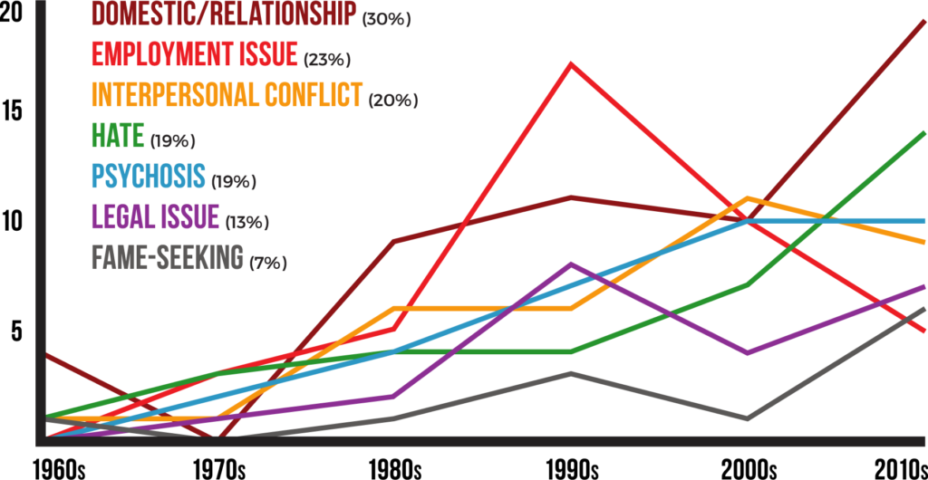

Figure , The motivations of mass shooters have varied over time (The Violence Project, 2022)

The dataset used is provided by the Violence-Project to be “used for the purpose of better understanding mass shooters and preventing mass shootings” (Peterson & Densley, 2022). It contains data on 168 mass public shootings (this is important as it will not include data on shootings that “are not attributable to any other underlying criminal activity or commonplace circumstance (armed robbery, criminal competition, insurance fraud, argument, or romantic triangle)” (Peterson & Densley, 2022).

One of the issues with staying politically neutral is that there is not very much verifiable data on how many mass shootings were prevented or failed to happen due to other reasons. All most all the data is only tracked after a shooting happens. Even with all the suggestions like more laws like the “Red Flag Laws” that allow people to report gun owners as being a risk and allowing law enforcement to secure the guns, there is no tracking on how effective these actually are.

**Hypotheses of this project**

This project is about determining if data analysists were able to accurately present their results without putting a political spin on it. In order to fairly compare the results on mass shootings presented by The Violence Project the basic question of neutrality is the issue. So to test that question, the following hypothesis will be tested:

The Hois that the analysis preformed and presented on the website of The Violence Project is accurate and politically neutral.

While the Ha is that the analysis is tilted towards the one political point of view or the other, but that it is not neutral.

The more that this project progressed, the less it became of the actual data and more about the approach and ethics used by The Violence-Project analysts and the ethics of data analytics in not only mass shootings but that used by both sides of the gun control argument in general. While there is data that can be used by the pro-gun ownership supporters like AR-15 style rifles are not used as often as handguns in shootings, most of the data is still collected with the point that private gun ownership is bad and needs to be stopped. The Violence-Project has done a fair job of not pushing the agenda that gun ownership is bad. However, their data has been used by “news” agencies like the U.S. international broadcaster Voice of America (VOA) to push the gun-control agenda.

**Methodology**

This project will stick to are strictly quantitative process of reviewing the data, in order to avoid the political arguments that bogged down such a sensitive topic. This project will review the data provided by The Violence-Project, and their analysis of that data. Then attempt to run similar analysis on the data using the statistical tools provided in the SAS Studio in SAS On-Demand for Academics suite. Utilizing the prebuilt functions such as line charts and series plots to graph out the data and look to see if it matches that provided. An example of the analysis if showed above in figure 1, and there is plenty of other analysis provided to validate as well. Once the data has been evaluated and if the verification confirms that the data was presented accurately, than the hypothesis that the Violence-Project Data that is accurately being presented can the confirmed.

**Limitations**

One of the major limitations is that the data is provided by The Violence-Project, and there’s no way to validate that they used the same dataset in their analytics. Other datasets use different values to determine the definition of what a mass shooting is, and thus cannot be used to do a comparison of the data against. Additional limitations are the relatively broad that categories used in some of the groupings. For example, as seen in Figure 1 above, the Violence-Project only classified someone different motivations, while this allows for a simpler visualization, it does not accurately and completely explain tables motivations. Additionally some of the analysis provided is kept broad and not broken down to show variance in issues by age, these examples show that there are limits already in the analysis done. One of the major limits, was that the data was saved as an Microsoft Excel document with multiple tabs, but it really was more in a database format and thus getting the data to run in any analytics program was not able to display the data the same is the way it was presented by The Violence-Project. One exception was the ability to compare how much of an effect psychosis had on the crime. The percentages were close on what was presented verses what was analyzed. Figure 2 shows the presents results while Figure 3 shows the tested results. 

Figure , Presented results from The Violence-Project Key Findings page (The Violence Project, 2022)

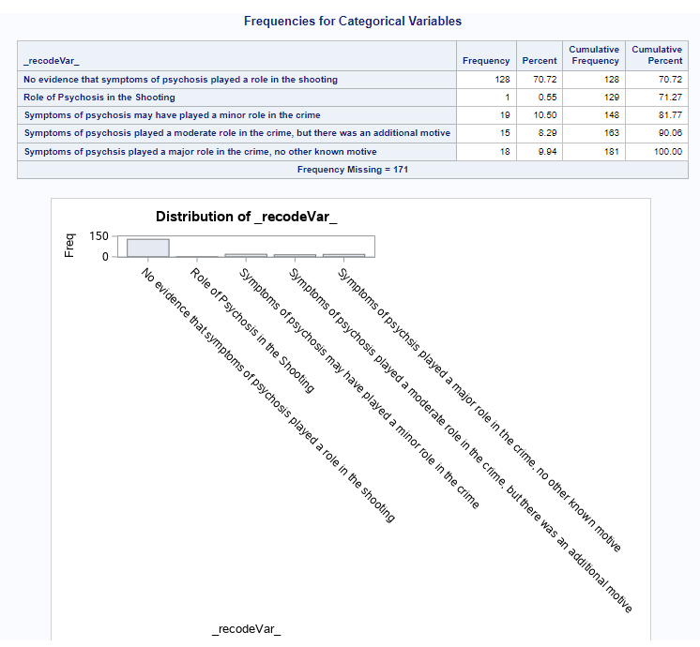

Figure , calculated Results from SAS Studio

**Ethics vs Morals vs Public Safety**

This project is about the ethics of The Violence-Project and to ensure that they were being honest about the results of their analysis, or if they were limiting the data to prove their own theory about mass shootings. One of the other ethical considerations, is how will the data be used, and is it sometimes ethical to manipulate data in order to help ensure public safety? In doing this research project, the ethical considerations to be concerned with are allowing at the author’s personal bias to influence the comparison results. This could be done in order to show that the Violence-Project is not accurately reporting their results, if the authored disagrees with the Violence-Project analysis, or it could be the author supports the analysis even if it doesn’t match if their philosophies are in-sync. The author needs to ensure his own ethics are not compromised by this highly political issue.

To help look at the ethical approach we need to look at what makes data analytics ethical to start with. A good place to start with is to make sure the data is collected in an ethical manor. This needs to ensure there is “a clear and accountable process is necessary to explain what information can be used and how it can be used” (Ho, Ali, & Caalsc, 2020, abstract). And this brings us to the point that while any ethical individual would easily see the challenges they are not at always as easy to comply with. Too many times politics and personal prejudices become involved and people do not make ethical decisions. It is because of this that laws and regulations are being developed to define how data should be used. The challenge is that “The use of a stated data protection code of conduct backed up by legal constraints is developing but in its infancy” (Harlow, 2018). Even different countries have different requirements on how data can be used.

Part of this project is to ensure that the data is used in an ethical manner and that the project will have some meaningful impact. However, since this project is designed to ensure that the original presenters were using the data that way, and the divisive nature of the topic, one of the points to consider is: would it ethical to manipulate the data in the name of public safety or not? Some people believe that “The ethical person changes how they respond to each situation even though their principles may stay the same” (weebly.com2, n.d.). So do data scientists have an ethical option to choose how they present the results? How others use the results presented is entirely on then, but in order for the data to be trusted and to have any air of being authentic, then it needs to be neutral. People are entitled to their opinions and beliefs but manipulating data to trick or force someone else into believing something is not an ethical position that should be tolerated.

**The Impact the Data Will Have**

Mass shootings are responsible for only a very small percentage of the deaths caused by gun violence in the United States, but most gun regulations motivated by a concern with mass shootings likely would have broader effects on gun violence generally. They would also likely affect lawful gun ownership and use. Accordingly, political ideology plays a role in gun regulation efforts, as supporters of gun rights usually muster opposition to these measures while gun rights skeptics push for them. (Viscusi, 2022).

There couldn’t be a better statement to sum up the impact that all this data will have. Neither side will be happy with the final results because as Benjamin Franklin once stated, “Those who would give up essential Liberty, to purchase a little temporary Safety, deserve neither Liberty nor Safety” (National Archives and Records Administration, n.d.).

**Conclusion**

In conclusion, this project attempted to prove that proper use of data can be a nonpolitical even on a very highly political topic. It proves that some data analysts are truly trying to ensure an honest and fair discussion about the causes of mass shootings. There are those who say that the United States has a uniquely American problem of a gun violence culture and point to countries that have super strict gun prohibition laws no having the same issue, what they fail to say is that those countries also have their own type of violence issues. “In USA Today’s collection of mass murders for the period 2006 to 2017, nearly a quarter were done without guns” (Cramer, 2019). Unfortunately the American issue has gotten more aggressive and frequent as people want their minute in the spotlight. Even as this project is being prepared, the United States has suffered several additional mass shootings. Interestingly while “Hate-motivated mass shootings and fame-seeking perpetrators have increased since 2015” (The Violence Project, 2022), there is not a lot of data on the cause of the increases. Also of interest is that of the 12 incidents tracked by The Violence-Project database only 3 of them were before the internet became common, and 5 of the 12 were since 2015 (and a 6th one in 2014), so half of the fame-seeking people are recent events. It begs the question of does the common use of social media provide people more of the desire to be famous and thus need to do something extreme to be that? Once upon a time there was a suggested cause for gun violence being video games and media keeps being refuted as a motivating factor.



While the games or media like movies or TV shows might not be the actual motivation, it really is hard to not wonder what impact they do have on some (especially the younger more impressionable) shooters. While people in the information systems professions like Cal State Fullerton professor Ofir Turel, have a vesting interest in keeping the blame from their field of expertise, they did honestly admit that their results were no consistent. Professor Turel did theorize that while certain playing less than a certain amount of time could offer a vent and possibly reduce violence, there is a point that those that played more than the break point might be more likely to act out (Lindell, 2020). However, another point would be the education about the capabilities of each of the weapons in the games and how that education helped mass shooters select their weapons to use.

As a society we need to identify the underlying causes and work to fix those if we ever want to see an actual decline in mass violence. Let us hope that individuals like those at the Violence-Project continue to honestly and fairly evaluate the data and present it without political bias. 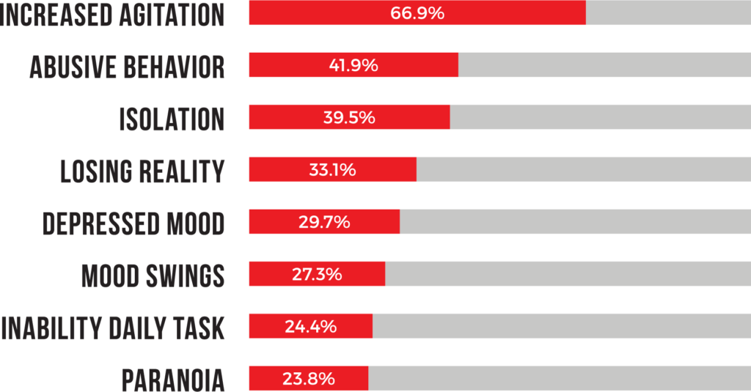

Resources

Cramer, C. E. (2019). Mass murder without guns. National Review. Retrieved from: https://ww w.nationalreview.com/2019/08/mass-murder-without-guns/

everytownresearch.org. (2022). Mass shootings in America. Everytown Research &amp; Policy. Retrieved from: https://everytownresearch.org/maps/mass-shootings-in-america/

everytownsupportfund.org. (2022). Home. Everytown Support Fund. Retrieved from: https://everytownsupportfund.org/

Harlow, H. (2018). Ethical Concerns of Artificial Intelligence, Big Data and Data Analytic s. *Proceedings of the European Conference on Knowledge Management*, *1*, 316–323.

Ho, C. W. L., Ali, J., & Caalsc, K. (2020). Ensuring trustworthy use of artificial intelligence and big data analytics in health insurance. *Bulletin of the World Health Organization*, *98*(4), 263–269. https://doi.org/10.2471/BLT.19.234732

Lindell, K. (2020). Relationship between video games and gun violence is not what you think. CSUF News. Retrieved from: https://news.fullerton.edu/2020/09/video-games-and-gun-violence/

National Archives and Records Administration. (n.d.). Founders online: Pennsylvania assembly: Reply to the governor, 11 November 1755. National Archives and Records Administration. Retrieved from: https://founders.archives.gov/documents/Franklin/01-06-02-0107

Peterson, J., & Densley, J. (2022). Mass Shooter Database. The Violence Project. https://www.th eviolenceproject.org/mass-shooter-database/

Shahid , S.,& Duzor, M. (2021). VOA Special Report: History of mass shooters. VOA Special Report | History of mass shooters. Retrieved from: https://projects.voanews.com/mass- shootings/

theviolenceproject.org. (2022). Most comprehensive mass shooter database. The Violence Project. Retrieved from: https://www.theviolenceproject.org/mass-shooter-database/

The Violence Project. (2022). Key findings - comprehensive mass shooter data. The Violence Project. Retrieved from: https://www.theviolenceproject.org/mass-shooter-database- 3/key-findings/

Vuscusi, W. K. (2022). The Ideological Divide on Gun Regulation: Polling data help explain why federal lawmakers could agree on compromise legislation to combat mass shootings. Regulation, 45(3), 14–17.

weebly.com2. (n.d.). The ethical person. The Moral vs. Ethical Man. Retrieved from: https://mor alsvsethics.weebly.com/the-ethical-person.html